SINGLE PRODUCER
MEMBERSHIP APPLICATION
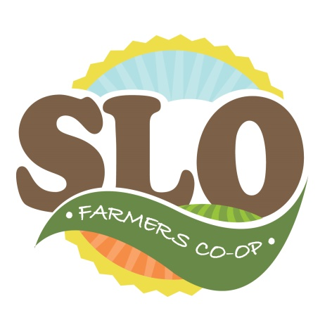
SLO Farmers Co-op

Thank you for your interest in joining the SLO Farmers Cooperative!
To begin the application process, complete the form below. The Board of Directors reviews each application and one of the board members will contact you once your application has been processed. Please note that submitting a membership application does not guarantee membership. A one-time fee of $750 is required to join.
Please return all applications to:
Rick Adamski
Membership Committee, chair
W2407 Hofa Park Rd.
Seymour, WI 54165
Or email to admin@slofarmersco-op.com

Business Name________________________________________________________________

Business Address_______________________________________________________________

City _____________________________________ State ______________ Zip____________________

Representative ___________________________________________

Business Phone __________________________ Phone (other) ________________________________

Email ______________________________________

- What Products do you want to sell through our cooperative? Please read our standards to ensure your products meet our standards.

- Please tell us about your farm. Where is your farm? How big is the farm? Who operates the farm? How long have you operated? What are your plans? (Please limit to one page.)

- Is your farm certified by an association? Please list all certifications for your farm.

- Please list your current licenses that you have from the State of Wisconsin and/or the USDA. (E.g. meat license, egg license, processing licenses.)

- Does your farm have a packing shed for packing produce? If yes, please explain.

- Does your farm have any structures to extend the growing season? If yes, please explain.

- Are you willing to change to production to better fit the sales needs of the cooperative? YES NO
- SLO requires $1 million in liability insurance. Do you have that? YES NO
- Please explain how you currently transport your products to your customers and explain if that is the same method that you plan to transport for our cooperative.

- Please explain your current labelling system for tracking purposes. Are you willing to modify this if a change would better serve the needs of our cooperative?

- Do you have a Food Safety plan in place (for the production of produce only.)? See On Farm Food Safety Plan: Resources from the University of Wisconsin Madison. All farms are required to file a food safety plan with SLO.
http://labs.russell.wisc.edu/farmfoodsafety/creating-a-food-safety-plan/plan-templates/

